Every day there is a discussion around the need for new crude oil takeaway pipeline capacity out of Western Canada. How did we get here?

**Supply and Demand**

Western Canadian crude oil production and supply has been increasing steadily for the past number of years, driven primarily by oil sands growth. According the CAPP 2018 Crude Oil Forecast, from 2010 to 2017, to Western Canadian supply (blended) increased from approximately 2.7 million b/d to 4.2 million b/d. Oil sands alone grew from 1.1 mb/d to 2.6 mb/d over this period.



Source: CAPP 2018 Crude Oil Forecast, Markets and Transportation

While Western Canadian supply has been increasing, the demand for crude oil in this market is relatively small when compared to other North American and global refining centres. Alberta, Saskatchewan and British Columbia together have nine refineries, totalling approximately 750,000 b/d of refining design capacity; actual receipts were closer the 545,000 b/d in 2017. Given the production is over 4 million b/d, a significant portion of the crude oil produced in this region is exported to refineries throughout North America and beyond.

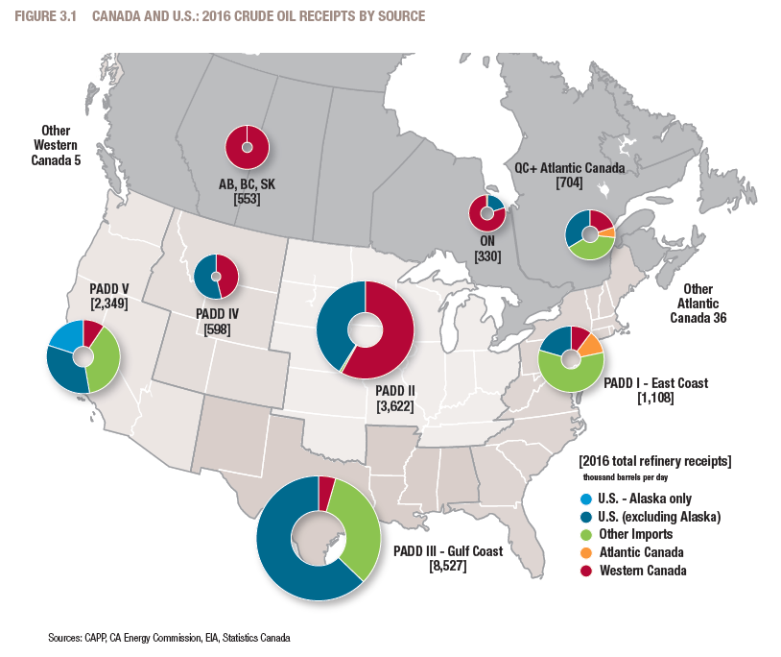

Source: CAPP 2017 Crude Oil Forecast, Markets and Transportation

**Transport and Price**

In 2018, crude oil takeaway capacity out of Western Canada exists via both pipelines and rail. Looking at pipeline capacity, the main lines out the region include: Enbridge Mainline, Kinder Morgan Trans Mountain, Enbridge Express, TransCanada Keystone. The total design capacity of all these lines is over 4 million b/d. However, given factors like outages for maintenance, and constraints downstream, CAPP estimated the actual 2017 pipeline takeaway capacity was closer to 3.4 million b/d. At 3.4 million barrels, Western Canada has lacked sufficient pipeline takeaway capacity relative to supply levels.

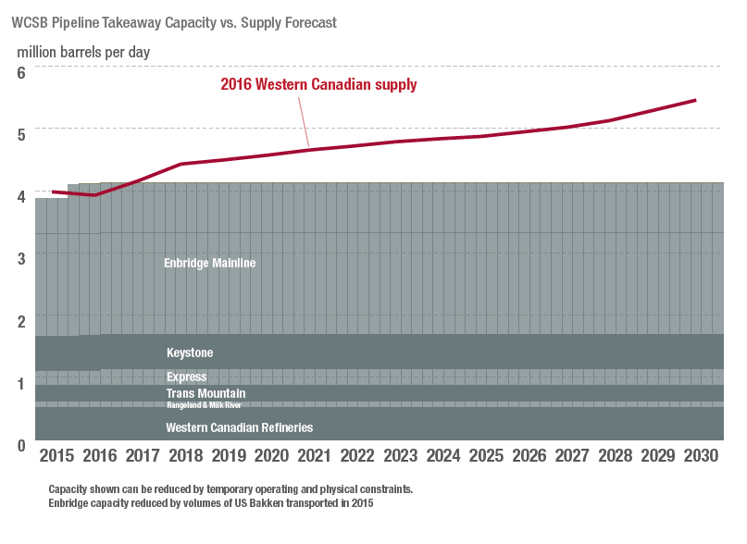

Source: CAPP 2017 Crude Oil Forecast, Markets and Transportation

Crude by rail is another option to transport crude oil out of Western Canada into other markets. Several uploading terminals have been built since 2012 to increase efficiency and lower the cost of transporting crude by rail. Barrels travelling by rail in 2018 through September averaged approximately 194,000 b/d, and it is expected that volumes travelling by rail will continue to increase until new pipeline capacity is built.

As you can see from above, and as has been the case with other producing regions in North America, supply has grown faster than the infrastructure needed to transport it out of the region. At several times over the past decade, the total number of crude barrels available for export out of Western Canada has exceeded the available pipeline capacity and rail car availability. The result of these bottlenecks has been significantly weakening prices.

With Western Canadian crude supply growth being driven by oil sands, the majority of crude produced is heavy and sour. The benchmark prices for this crude is considered to be Western Canadian Select. However, to understand the price relative to other markets, many crude prices are shown as differentials. In this case, this is best shown in the difference between Western Canadian Select (WCS, Canadian heavy benchmark) and West Texas Intermediate (WTI, US light sweet benchmark). The WCS-WTI differential, at a most basic calculation, represents the quality differential between a light, sweet barrel located in the US Midwest (WTI) and a diluted bitumen (heavy, sour) barrel produced in Alberta. The price differential represents the quality difference between the two types of crude, as well as the locational difference between the two. If all of the fundamentals of supply and demand are in balance, the difference between those two would be less than $10/bbl, but it is rare that all factors are in balance. In the cases when we have insufficient takeaway capacity, the price can be set by the next available transport option, like rail, which is more expensive than pipeline, and if that is unavailable, then it could represent the cost of putting the barrels into storage, or finally the cost of shutting in the production. As mentioned above, there have been several times over the past decade when a lack of pipeline capacity has resulted in a much wider differential between WTI and WCS; in 2012, 2013 and currently, the differential has been wider than $25/bbl. Today, world prices for crudes are in the $50/bbl range, but WCS is pricing around $15/bbl.

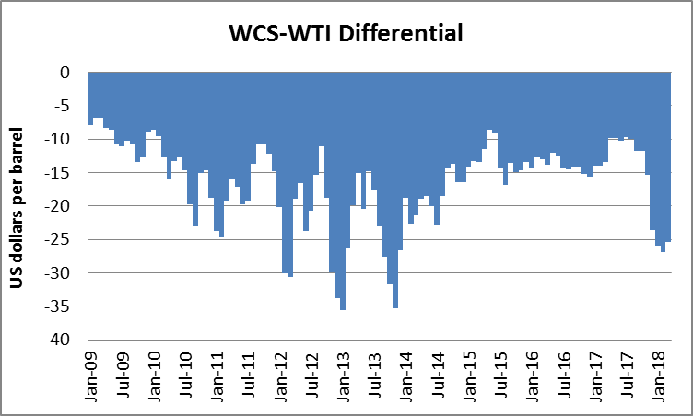

**The global crude market**

The other key factor to remember in this conversation is that Western Canada is not the only producing region, (and while yes there are differences between light, sweet barrels and heavy, sour barrels), the barrels from this region compete with barrels from US and global regions. The barrels compete for markets, investment dollars, and transport. For instance, capacity on the Enbridge mainline may be over 2 million b/d (?) out of Western Canada, but Bakken barrels are loaded further loaded down the line, effectively reducing the receipts at the Canadian point.

The resurgence of production from the US, primarily in the form of tight oil (light sweet barrels) has had a significant impact on global crude markets and flows. As a result of tight oil and fracking, US production has grown from 5.5 million b/d in 2010 to 9.4 million b/d in 2017 (EIA).

Over this same time frame, there has also been growth in crude oil supply from global regions, although more mixed that in North America. For example, growth in Latin American production declined over the 2010-2017 timeframe, but areas like Middle East and Russia have grown over the same time period. (check and add numbers)

The world’s continued growth in supply over this time frame has been ultimately driven by growth in demand for crude oil and its resulting refined products. Since 2010, global demand has increased from 87.4 million b/d to 97.8 million b/d.

**What does the future hold for global crude markets? And more importantly (because we live in Alberta) what does this mean for Western Canadian barrels and North American flows?**

As we looked around to answer this question, we found the need for a model built for public discussion that was transparent with what assumptions were included. Darkhorse Analytics and the University of Alberta, School of Business, Energy group, have come together to build CrudeFX.

**What is CrudeFX?**

Overall summary

**How is it built?**

Technical stuff

**What assumptions are included?**

* All existing North American crude oil pipelines (as of Q2 2018)
  + Assumptions were made regarding ranges for heavy and light capacity based on historical deliveries and internal estimates
* North American existing refining capacity, summarized into PADDs, based on Canadian and EIA data
* Global refining capacities are based on IEA outlook data (WEO/Oil)
* Pipeline tolls across North America from NEB and FERC filings
* Rail capacity ranges (heavy and light) are based on a combination of historical flows where available (NEB, EIA), company research and internal estimates
* Tanker costs for North America (Jones Act and non-Jones Act) and global movements based on research and internal estimates
* Supply and demand for historical validation is based on CAPP, EIA, IEA, as shown the report above)
* Future supply and demand assumptions are from CAPP for Canada, EIA for US and IEA for global regions, see below
* Future refining capacity based on EIA and IEA oil reports, with assumptions on light and heavy capacity calculated based on internal calculations
* Future pipeline expansions out of Western Canada were based on research of publicly estimated in-service dates (https://www.bnnbloomberg.ca/these-are-possible-solutions-to-canada-s-record-low-oil-price-problem-1.1150281)

**Supply and demand**

As the world moves forward over the next 5 years, the IEA expects that global oil demand will continue to grow, from 97.8 million b/d in 2017 to 104.7 million b/d by 2023. (Oil 2018)

On the supply side, strength in output will continue in order to meet this demand growth. In general, US tight oil production will continue to drive growth and is expected to increase by 3.7 million b/d by 2023, to total almost 17 million b/d. One of the interesting occurrences over this period is that US domestic consumption of refined products is expected to fall – and because of this, the EIA predicts that the US will become a net exporter of crude oil by 2022. It is expected that US tight oil will continue to be the main driver of this growth, accounting for 65% of US domestic production during the forecast period to 2030.

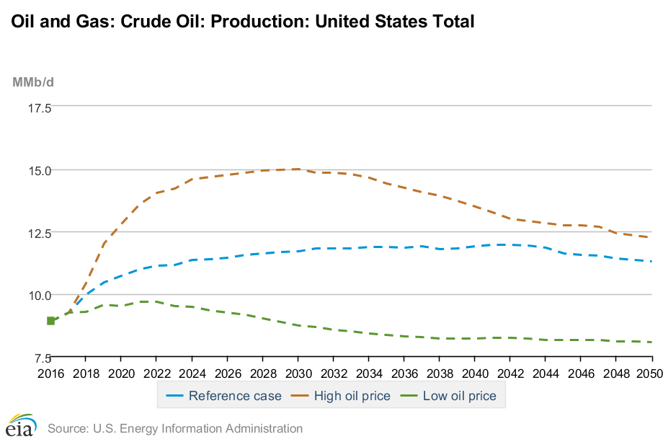

Source: EIA AEO 2018

The IEA’s production expectation is for global growth to be driven by Middle East and Latin America. Specific to each region, there is an expectation of decline in nearly all OPEC member countries outside of the Middle East, with the exception of Libya who have managed to increase production despite the ongoing civil unrest threatening its oil infrastructure. The economic crisis and political instability in Venezuela is expected to persist, therefore the IEA predicts that they will unlikely increase production in the forecast period. The majority of Latin American crude oil production growth will come from Brazil. Despite new production from projects in east Siberia and the Arctic, total Russian oil production is projected to decline through the forecast period as growth slows in the mature production regions of western Siberia and Volga-Urals. Overall, total world oil production is expected to grow to nearly 100 million b/d by 2030, with 42% of this coming from OPEC.

|  |  |  |  |
| --- | --- | --- | --- |
| Oil production (mb/d) | | | |
|  | 2017 | 2030 | Growth |
| Middle East | 32.0 | 35.4 | 0.8% |
| Latin America | 10.0 | 12.2 | 1.5% |
| Russia | 11.3 | 9.7 | -1.2% |

Source: IEA WEO 2017

**What about Western Canada?**

As per CAPP’s 2018 outlook, supply in Western Canada is expected to grow from 4.2 million b/d in 2017 to approximately 5.2 million b/d in 2023.

**Refining capacity expansions**

The IEA Oil report expects an increase in global refining capacity, by 7.7 million b/d. The growth will occur in the Middle East (2 mb/d) and Asia (3.6 mb/d). We have assumed that new refining capacity will be a mix of heavy and light capacity.



**Transportation assumptions**

We have assumed that rail can grow with few limits. In terms of pipelines there are three potential Canadian projects.

Enbridge Line 3 Replacement

This project involves the full replacement of the existing Line 3, which runs from Hardisty, Alberta to Superior, Wisconsin. The project started construction in 2017 and is expected on-line in late 2019. The capacity of the line will be 760,000 b/d, of which 370,000 b/d is incremental capacity, and it will carry light, sweet and heavy, sour crudes.

Keystone XL project

TransCanada’s Keystone XL is a proposed pipeline running from Hardisty, Alberta to Steele City, Nebraska. The line will transport heavy, sour crude and will have a capacity of 830,000 b/d. Construction is expected to begin in the first half of 2019 and we are assuming the project will be in-service in 2021.

Trans Mountain Expansion

The Trans Mountain Expansion Pipeline expansion is a project that will twin the existing Trans Mountain Pipeline. The project starts near Edmonton, Alberta (Strathcona County) and ends in Burnaby, British Columbia. Currently, the pipeline transports 300,000 b/d and with the expansion capacity will increase to 890,000 b/d. In addition, the Westridge Marine Terminal will be expanded to increase its monthly tanker limit from 5 to 34. The existing pipeline will continue to carry refined products, synthetic crude oils, and light crude oils, while the expansion is expected to carry heavy, sour crudes.

**Scenario results and key findings**

There are 4 main scenarios:

* 2022 vs. 2018 assuming no new Canadian pipeline capacity
* 2022 with Line 3 is completed
* 2022 with Keystone XL is completed
* 2022 with Line 3 and Keystone XL completed

The model assumption is that Western Canadian production grows ~350,000 b/d between 2018 and 2022.

Base Case 2022 vs 2018

With demand, production and refining capacity growing, there is more opportunity for Canadian heavy barrels to reach the US Gulf Coast – relative to 2018, 290,000 b/d more heavy comes via rail, bringing total heavy flows to 600,000 b/d between the two transportation modes.

One of the interesting findings of this overall is that based on our assumptions of heavy and light refining capacity growth and production growth and declines, there are insufficient heavy barrels to meet the global demand for heavy. Given the large growth of refining capacity East of Suez, the incremental barrels from Middle East stay in the Eastern Hemisphere, while falling LATAM barrels result in US Gulf Coast cokers not being full. It is likely that if Canada’s growth was higher, the incremental barrels would travel by rail to USGC.

Scenario with Line 3 in 2022 vs 2022 with no additional pipe

Given the assumption that Line 3 will carry a variety of crudes, the result of line 3 being completed is 344,000 moving off rail and into pipeline. These new pipeline barrels that are light (180,000) land in PADD II and push back light barrels previously moved in from PADD III. The incremental heavy barrels (163,000) are transported via PADD II but eventually land in PADD III. Why don’t more barrels come by rail? They end up going to PADD V. The model finds it more economic to take those barrels on TransMountain now that some of those light barrels are moving to PADD II and fill that space with heavy destined for PADD V market.

Scenario with Line 3 and Keystone XL vs 2022 with no pipe

The previously transported rail barrels (366,000) are moved onto pipeline. A large part of the barrels go from Alberta to PADD II (N or M) are moved further down the line to PADD II S and others go directly to PADD III. All those barrels come at the expense of PADD II N or M, who is now shorted almost 900,000 barrels. Craig’s comment – is Line 3 made redundant by KXL? Or at least, Enbridge will be shorted all those barrels.

Scenario Line 3 and KXL is exactly the same as KXL only

**Sensitivities**

Assumes no coker capacity increases